**Activity 3:** **Implementing BMI Calculator**

**UI Components:**

* **EditText** for weight (kg) and height (feet) input.
* **Button** to trigger BMI calculation.
* **TextView** to display BMI and category.

**BMI Calculation:**

* Capture weight and height input.
* Convert height from feet to meters (1 foot = 0.3048 meters).
* Calculate BMI using:

**BMI=Weight (kg) / Height (Feet)**

* Display BMI and category (Underweight, Healthy, Overweight, Obese, Extremely Obese).

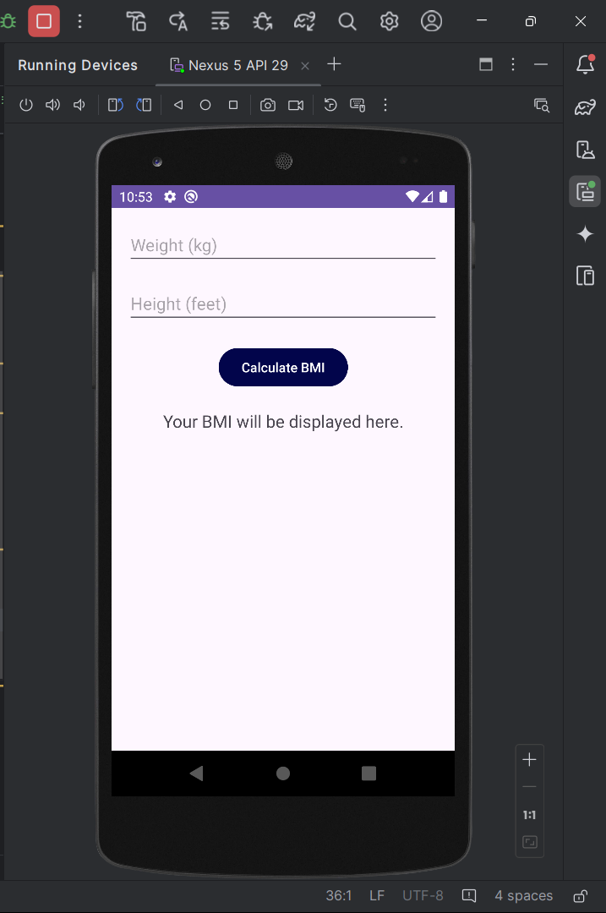

**2. MainActivity.java**

* Captures user input, calculates BMI, and shows the result.
* BMI ranges:
  + Underweight: BMI < 18.5
  + Healthy: BMI 18.5 – 24.9
  + Overweight: BMI 25 – 29.9
  + Obese: BMI 30 – 34.9
  + Extremely Obese: BMI ≥ 35

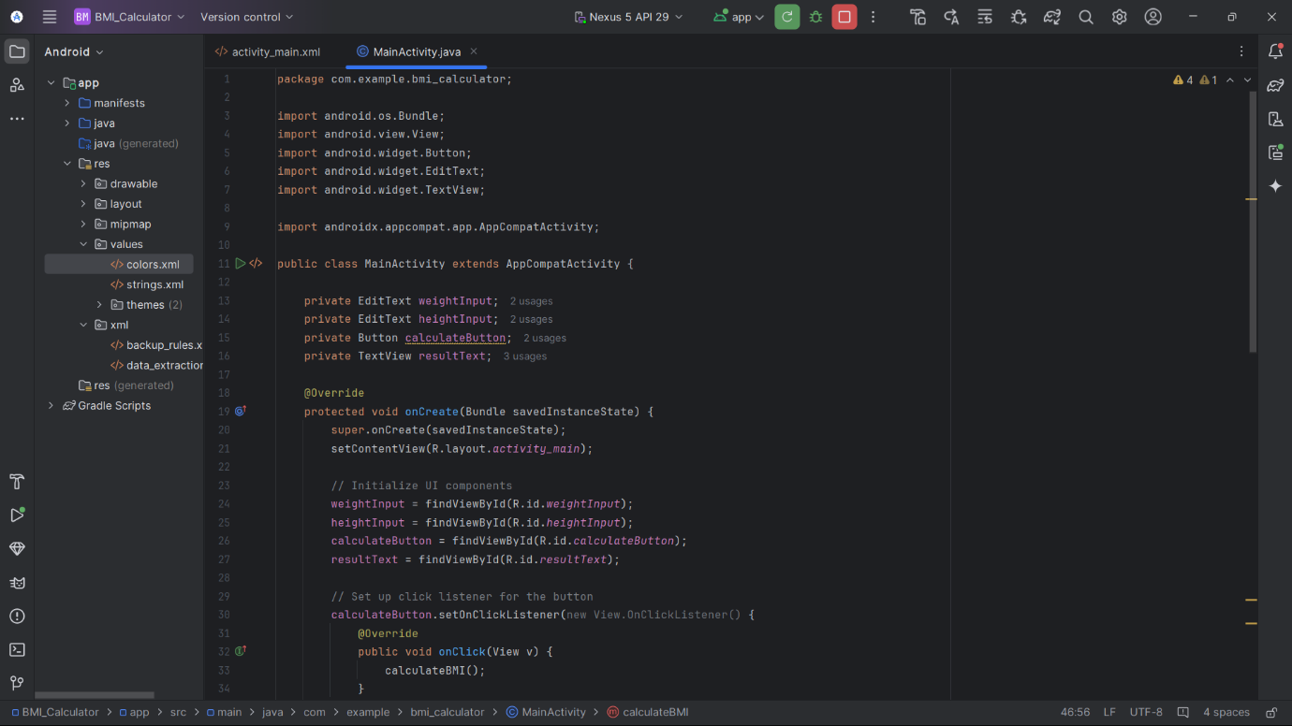

**3. activity_main.xml**

* UI layout includes EditText for weight/height, a Button for BMI calculation, and a TextView for displaying the result.

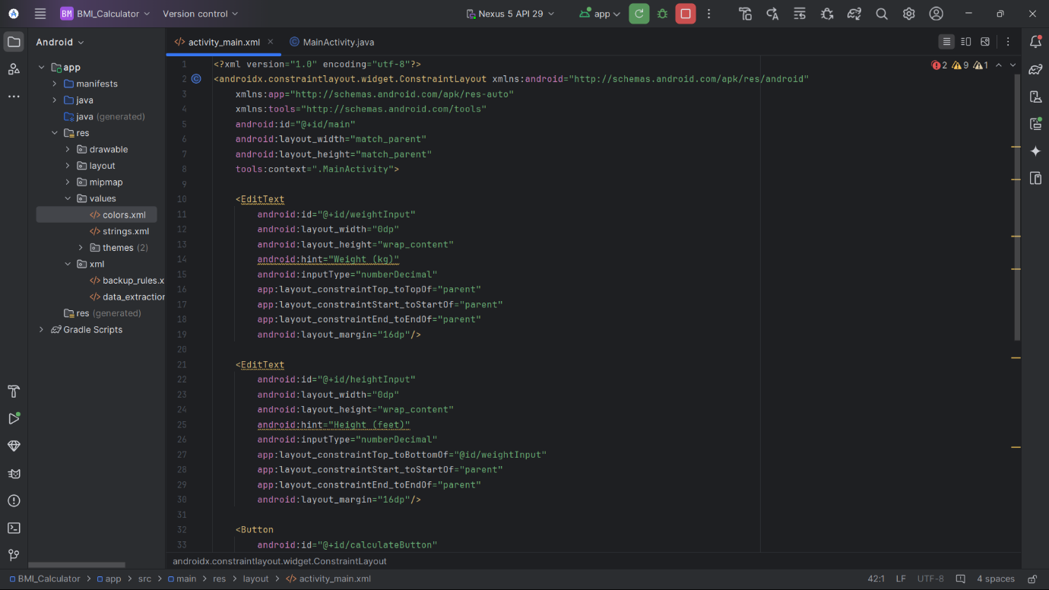

**Output:**

